NSC Technical Subcommittee Call Minutes – October 15, 2024
Participation [by region]:
1: Sara Johnson - NH
3: Carrie Wintersteen, Samantha Harmon, Luke Hershey, Jeremy Hancher & Lee Ann Briggs – PA
4: Griffin Jones – FL; Donovan Grimwood – TN; Allison Hall – KY; Tony Pendola – NC
5: Tamara Girard – OH; Kaitlyn DeVries – MI; Lisa Ashenbrenner-Hunt & Jennifer Feyerherm – WI; Aneka Swanson, Emily Ohde, & Samantha Connolly – MN and Tammy Haug & Mark Stoddard – IN
7: Bob Randolph – MO; Jennifer Wittenburg – IA and Keely Hutchinson, Nancy Larson, Cris Brazil & Leena Divakar – KS
8: Kaitlin Urso, Jesse Walters & Jarrett Vigil – CO; Eleanor Divver – UT and Michael Gustafson – MT
9: Griffin Hadlock & Alex Torres – AZ

Speaker: Michael Liebert, Global Client Director, ALL4

Tech-Subcommittee: https://nationalsbeap.org/committees/technical

** This presentation was recorded and will be posted on the National SBEAP YouTube channel at https://www.youtube.com/channel/UC5PupYpZ1W6IG8CtzCINK8Q **

The New PM2.5 National Ambient Air Quality Standard
Michael Liebert, Global Client Director, ALL4

This presentation will address the revised PM2.5 NAAQS. How many areas will likely be in nonattainment and what impact will the new SIL (Significant Impact Level) have on permitting. The process for designations will be discussed along with the implications for designation, permitting, compliance and enforcement.

Bio

Michael Liebert
Global Client Director
All4, Inc.
MLiebert@All4inc.com

Mr. Liebert is a Directing Consultant in ALL4’s St. Louis, Missouri office. He has been working in the environmental compliance industry for 25 years and specializes in environmental regulatory applicability analysis, environmental compliance for manufacturing industries, preparation of emission inventories, environmental auditing, Title V operating permit applications, New Source Review (NSR) air permit applications, Maximum Achievable Control Technology (MACT) compliance, State Construction Permitting, and Toxic Release Inventory (TRI) reporting.

He has assisted in environmental permitting and compliance projects for facilities across the country including Missouri, Illinois, Iowa, Kansas, Nebraska, Pennsylvania, Oklahoma, Ohio, Colorado, Kentucky, Arkansas, and California.

Mr. Liebert was on the Board of Directors for the St. Louis Air & Waste Management Association for over 3 years and is also a member of the Gateway Society of Hazardous Waste Material Managers.

Mr. Liebert earned a Bachelor of Civil/Environmental Engineering from the University of Kentucky and a Master of Engineering Management degree from Washington University in St. Louis.

Mr. Liebert resides in Wildwood, MO with his wife and two kids.

References – micron size comparison

Micron Size Comparison Chart

Particle | Particle Size (Microns)
postage stamp (1 inch) | 25,400
beach sand | 100-2,000
eye of a needle | 1,230
pollens | 10-1,000
saw dust | 30-600
coffee | 4-400
dust mites | 100-300
table salt | 120
human hair | 70
lower limit of visibility (naked eye) | 40
household dust | 40
mold spores | 10-30
white blood cells | 25
talcum powder | 10
red blood cells | 8
bacteria | 3
spider web | 2-3
lead dust | 2
corn starch | 0.1-0.8
tobacco smoke | 0.5
90% of all oil contaminants | 0.5-2
0.001 millimeter | 1

https://www.clearstream.ca/micron-size-comparison-chart

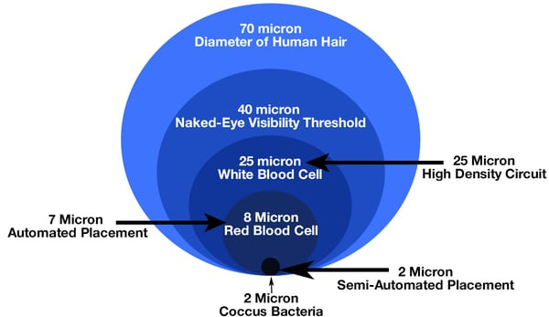

https://www.bench.com/setting-the-benchmark/how-big-is-a-micron

Inhalable Particulate Matter and Health (PM2.5 and PM10) - https://ww2.arb.ca.gov/resources/inhalable-particulate-matter-and-health

Future topics:
- November 19: Demonstrating the MiEnvrio Portal & Oregon’s Your DEQ Online platforms, Kaitlyn DeVries, EGLE and Hillarie Sales, OR DEQ
- December 17: Open forum discussion possibly relating to 2025 Annual Training
- January 21, 2025: Waste Tire Management in the US, John Sheerin, Director End of Life Tire Programs, US Tire Manufacturers Association; Susie Steinbach, Liberty Tire Recycling, and Kirsten Clemens, EGLE’s (Michigan) Scrap Tire Specialist
- February 18: Printing topic, Gary Jones, Vice President, Environmental, Health & Safety Affairs, PRINTING United Alliance
- March 18: Perc Drycleaning NESHAP final rule (Subpart M), Reginald Reginald, Lead EPA Subpart M Rule Writer - Goodwin.Reginald@epa.gov
- April 15: EV charging and alternative fuels for fleets (many hurdles for small businesses to overcome), Belinda Breidenbach, ID
- May 20: To be determined
- June 17: Vape pen disposal - both from a nicotine and a Li battery perspective, Jacob Larson, KSU
- Other 1: AERR (Air Emissions Reporting Requirements) & MM2A (Major MACT to Area) Status and Final Steps
- Other 2: EPA Air Toxic Screen

Next Call: November 19
1 pm CDT (2 pm EDT) (3rd Tuesday of month)

