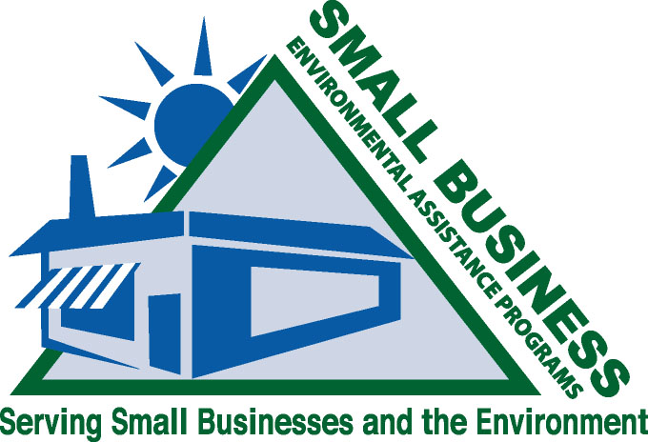

Environmental Assistance Initiative for Small Businesses

Congress, in anticipation of the regulatory burden that would be placed on small business as a result of the passage of the 1990 Clean Air Act Amendments (CAAA), added Section 507 to Title V of the CAAA requiring each state to establish a Small Business Stationary Source Technical and Environmental Compliance Assistance Program (507 Program). The 507 Program, which was required to be incorporated into a State Implementation Plan (SIP), consists of three components: 1) a small business environmental assistance program (SBEAP); 2) a small business ombudsman (SBO); and 3) a compliance advisory panel (CAP). The 507 Programs became operational in 1994.

Today’s demand for compliance assistance includes not only the additional tens of thousands of sources affected by the new area source NESHAPs, but also goes beyond air regulations. Small businesses request guidance on regulations pertaining to the storage and disposal of solid, liquid, and hazardous wastes; wastewater discharges; stormwater runoff; and spill prevention, to name a few. Some SBEAPs have addressed this need by finding ways to expand their 507 Programs to provide environmental assistance that goes beyond just the air regulations. General outreach to small businesses is occurring through workshops, publications such as fact sheets and compliance calendars, phone consultations, and onsite visits. Unfortunately, resource reductions may reduce the number of programs providing comprehensive environmental assistance and others may be limited in the amount of comprehensive assistance provided. In addition, approximately half of the SBEAPs do not provide comprehensive assistance at all, and some states have eliminated their SBEAP, CAP and SBO altogether. At a time when economic growth is critical and small business is challenged with economic uncertainties, access to comprehensive environmental assistance is essential to improve bottom line performance and to assist when the potential for expansion exists.

While the funding of the 507 Programs has dramatically decreased over the years, the regulatory responsibilities of small businesses continue to increase. To address this disparity, in April of 2007, the Environmental Council of States (ECOS) sent a letter to the Administrator of the U.S Environmental Protection Agency (EPA) asking that a dialogue be started between EPA and SBEAPs to find ways to deliver comprehensive compliance assistance to small business. Subsequently, the EPA Office of Small Business Programs was made responsible for scheduling these meetings which will include high level representatives from all of EPA program offices. Actions items for these meetings include:

- Outline the evolution of SBEAPs: where they are and how they got there.
- Build a national environmental compliance assistance initiative.
  - Identify EPA programs’ ongoing and upcoming compliance assistance initiatives.
  - Identify federal resources available to expand air-only SBEAPs to comprehensive SBEAPs and help maintain those SBEAPs currently operating a comprehensive program.
  - Determine communication tools that should be used to improve coordination between the SBEAPs and all EPA programs.
  - Discuss ways for the SBEAPs and EPA to improve coordination of compliance assistance activities within the states and regions.
  - Determine how duplication of efforts can be avoided and how we can utilize each other’s strengths.
  - Describe ways to improve awareness of the SBEAPs beyond the Office of Small Business Programs to include all EPA programs.
- Identify pilot projects that SBEAPs and EPA can collaborate on to demonstrate mutual value to each other and small businesses.

The SBEAPs and states are eager to begin these discussions so that small business can receive the assistance they desperately need. For a more detailed discussion of the Section 507 programs, please read the “Comprehensive Environmental Compliance Assistance Program Background Document” dated October 29, 2008. This document was prepared by the Multimedia Subcommittee of the SBO/SBEAP National Steering Committee and is located at the following location:
http://www.smallbiz-enviroweb.org/sba/multimediafiles/BackgroundECOSDocument_102908.pdf.

