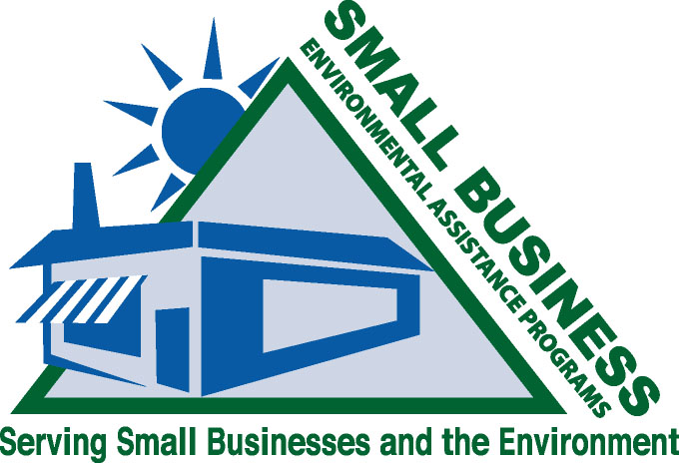
Guidelines
SUBCOMMITTEE

2007 SBO/SBEAP National Conference, St. Paul, Minnesota

June 18-21, 2007

Our Mission
To explore the usability and relevance of EPA’s guidelines for implementation of Section 507 of the 1990 Clean Air Act Amendments throughout the SBAP/SBO network. Once the relevance and usability are determined, create a dialogue with EPA to discuss modifications.

Background
The subcommittee was created from the working session of the 2002 National Conference in Chicago. The following questions were posed to attendees:

- Are the 507 programs working as intended in the Clean Air Act?
- Are the eight EPA guidelines for the 507 programs realistic and still applicable or are they outdated?
- Do the 507 programs need a formal review to become more standardized?
The subcommittee began its task by creating a survey based on the Clean Air Act requirements and EPA’s Guidelines to determine the usability and relevance of the guidelines. The 2003 National Conference Working Session in Baltimore gave the subcommittee an opportunity to validate the questions to be posed in the survey by having participants discuss the guidelines. Soon thereafter, the survey was available online for each state to complete. The survey data was reviewed and analyzed by the Guidelines Subcommittee. A summary of the results was then posted online at http://www.smallbiz-enviroweb.org/guidelines/survey/results.asp.
The subcommittee’s intent at this point was to discuss the survey findings with EPA and the National Steering Committee to determine the next steps. However, after the 2004 national conference and in light of the multimedia initiative, the subcommittee agreed that it was best not to begin these discussions until it was determined whether the 507 programs would be required to provide multimedia assistance.
Following the 2006 National Conference in New Hampshire, the subcommittee was asked to revise and edit the National Steering Committee guidelines. After many hours of hard work by everyone involved, the subcommittee presented the steering committee with the revised guidelines in the spring of 2007.

The Next Step
The subcommittee is at a crossroads: should the 507 guidelines still need to be revised in light of the many new training resources developed by PRIZIM. The committee will discuss whether it wants to proceed with this effort at the 2007 National Conference and will make its recommendation to the National Steering Committee.

Join us for the Guidelines Subcommittee Session on June 20 at 1:30 pm at the National SBEAP/SBO National Conference in St. Paul, MN.

Current Members
Richard Rasmussen (VA)
Sally Tarowsky (Chair/ID)

Special thanks go to former subcommittee members, Linda Sadler and Terry Polen, for all of their hard work and dedication!

