September 20, 2007

The Honorable Richard J. Durbin
309 Hart Senate Office Building
Washington, D.C. 20510

Dear Senator Durbin:

In 1990, Congress established the Small Business Environmental Assistance Programs (SBEAP’s), under Section 507 of the Clean Air Act (CAA) to provide free technical assistance to small businesses with air related environmental regulations. Each program, in all 50 states, the District of Columbia, and two territories, is designed to meet the specific needs of local small businesses and advocate for small businesses on air-related environmental issues. Through these programs, small businesses, who often cannot afford to hire environmental consultants and attorneys, receive free one-on-one assistance, easy- to-understand guides and publications, as well as valuable recordkeeping tools and training programs.

Millions of businesses reach out to these programs each year, but there are obstacles to providing these companies with the comprehensive assistance they need. Currently the SBEAP’s are only authorized to provide assistance with air quality regulations yet the need for assistance with water and waste regulations is equally important to insure not only compliance with complex environmental regulations but also protection of our environment.

Presently, these programs receive no federal funding and are operating with shoestring budgets and limited staffing across the country.

In Illinois, the Small Business Environmental Assistance Program is housed at the business assistance agency, the Department of Commerce and Economic Opportunity. I have seen firsthand the importance of these programs to the small business community. In FY 2007 the Illinois SBEAP, with a very limited budget and a staff of three, were able to provide:

- 3589 training hours;
- nearly 1000 helpline consultations;
- 6600 recordkeeping tools utilized by small businesses; and,
- 50-70% reductions in noncompliance through joint voluntary education and assistance projects with the Illinois EPA Bureau of Air.

The need is clear and the results are impressive, but we can do more to enable our small businesses to focus their time and money on growing their companies rather than struggling to understand unclear and onerous environmental regulations. Illinois’ small businesses need and deserve well-rounded assistance with all their environmental needs not just air related issues.

The National Compliance Advisory Panel of small businesses has developed the attached Comprehensive Small Business Environmental Assistance Legislative Initiative to further explain the need to take these programs beyond air compliance. Upon review of the initiative, I’m sure you will agree this is a worthy cause.

I urge you to sponsor legislation in support of this initiative authorizing and appropriating funding for the Small Business Environmental Assistance Programs to assist small businesses with their comprehensive environmental needs: air, land and water.

If you would like to become involved in this initiative or have questions regarding the Illinois Small Business Environmental Assistance Program, please contact me or Annette Fulgenzi of my staff at 217/524-5199.

Sincerely,
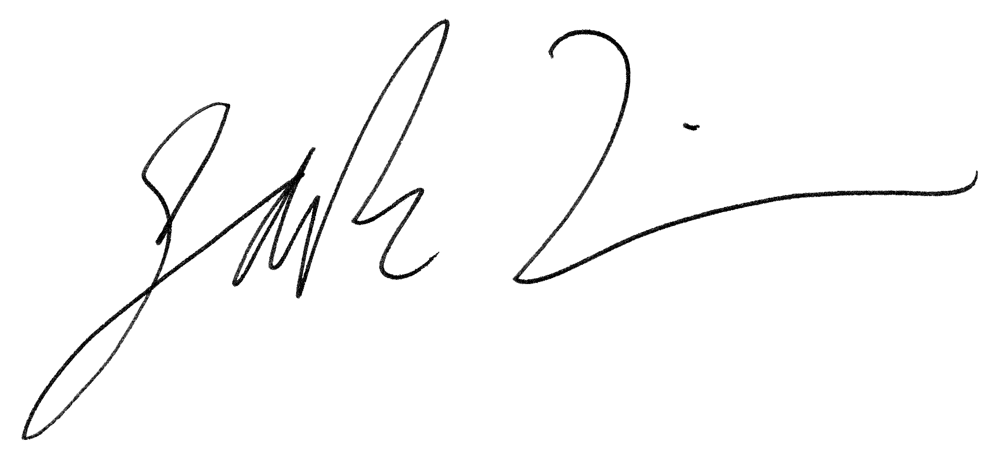

Jack Lavin,
Director
Illinois Department of Commerce & Economic Opportunity

Attachment: Comprehensive Small Business Environmental
Assistance Legislative Initiative

