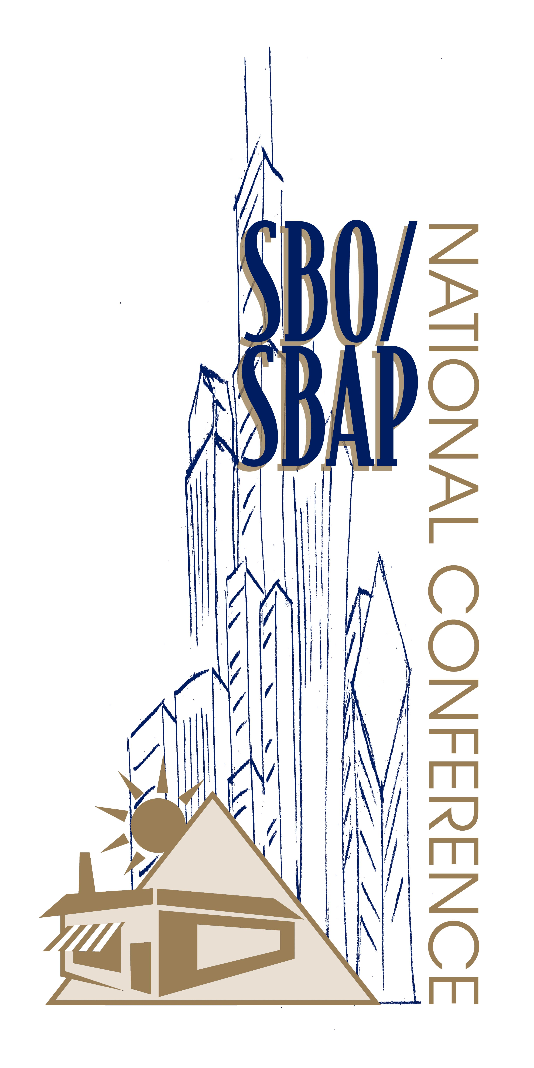
2002 SBO/SBAP National Conference
Newcomer Training Mentoring Match Form
Chicago, Illinois
June 29-July 3, 2002 3:00-5:00 PM
Please complete the information form below for your state. Please identify each newcomer from your state who will want to be matched with a Mentor. Also, please indicate who from your state would want to volunteer as a mentor. Please make the Newcomer Training a success by completing the enclosed form and returning it to Kenya Carroll by May 1, 2002. Fax: 859/323-1907 or e-mail ckeny2@uky.edu Participation in the Mentoring Match program is not required to attend the training but it is encouraged!
Newcomer Training Mentor/Newcomer Information

State:__________________________________________________

Newcomer(s) Name and Occupation:_______________________________________________________________________________________________________________________________________________________________________________________________________________________________________________________________________________________________________________________________

Mentor(s):__________________________________________________________________________________________________________________________________________________________________________________________________________________

Newcomer Training Agenda
Introduction
Orientation to SBO/SBAP
Tools for the Newcomer
Mentor Assignments
Questions

