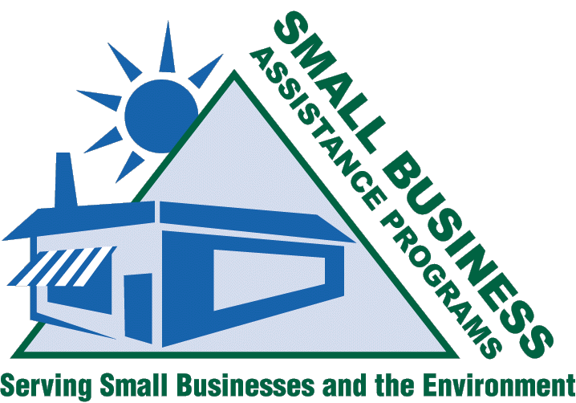
Performance Measurement
Working Session:
A Summary

Overview
During the 2004 SBO/SBAP National Conference in Sacramento, California on June 4, 2004, a working session was held to discuss performance measurement.

With the current state of the economy, states across the country are under pressure to reduce program expenses without sacrificing key services. Non-regulatory compliance assistance programs, such as the 507 programs, are at high risk of losing some or all funding. Is now the time to consider performance measurement for our program network in order to demonstrate measurable environmental improvement from our activities?

We hoped to answer this and many other questions during the working session.

Summary
The working session consisted of two presentations from EPA offices and one breakout session. The National Center for Environmental Innovation (NCEI) and the Office of Enforcement and Compliance Assurance (OECA) both presented a different approach to the same problem: how do you measure environmental improvement?

The working session also allowed time for groups to discuss performance measurement within their programs and agencies during a breakout session.

EPA’s National Center for Environmental Innovation (NCEI)

Yvonne Watson and Brian Swett

The National Center for Environmental Innovation is a part of the Office of Policy, Economics and Innovation. Their mission is to focus on finding new ways to improve environmental results. Working with EPA programs, and with states, businesses and communities, the center seeks to solve challenging environmental problems through new ideas, creative partnerships, and sound analysis.

The working session introduced participants to NCEI’s approach to performance measurement underway at NCEI, their use of a logic model concept to help create a common understanding and terminology of performance measurement, and provided participants with an interactive small-group exercise on the logic model tool. This session helped participants learn how to use this approach to develop performance measures for their own programs.

EPA’s Office of Enforcement and Compliance Assurance (OECA)
Angela Baranco, Rochelle Kadish, and Kenya Stump (KSBEAP)

The Office of Enforcement and Compliance Assurance (OECA), working in partnership with EPA Regional Offices, State Governments, Tribal Governments and other Federal agencies, ensures compliance with the nation's environmental laws. Employing an integrated approach of compliance assistance, compliance incentives and innovative civil and criminal enforcement, OECA and its partners seek to maximize compliance and reduce threats to public health and the environment.

The working session introduced participants to OECA’s approach to measuring environmental assistance outcomes, which included defining goals, defining common terms, determining activities and measures to achieve goals, and comparing data collection methods. OECA also presented a specific example of outcome measurement used in Region 9. Lastly, the Kentucky Small Business Environmental Assistance Program presented the results from a recent state survey that measured compliance assistance outcomes.

Workgroups
Between the two presentations, participants broke out into 10 separate workgroups to begin discussing performance measurement. The goal of each workgroup was to decide if they wanted the National Steering Committee (NSC) to create a subcommittee to look in to developing a program framework for performance measurement and to provide one or two bullet items for the NSC to consider if it were to go forward with developing such a framework.

Workgroup leaders presented their items for consideration at the end of the working session. See Table 1 for a summary of the discussions.

Conclusion
The workgroups overwhelmingly felt that performance measurement was an important issue that the 507 programs should consider and decided that the NSC should create a subcommittee to address it. However, there were many issues of concern that participants felt the NSC should consider when proceeding with performance measurement:

- Determine why measurement is important to the programs.
- Rely and build on existing tools, models, surveys, etc.
(Note: The Small Business Environmental Home Page hosts a database of these tools already. Visit: http://www.smallbiz-enviroweb.org/perfmeas/perf.html)
- Develop common definition of measures the program wishes to use.
- Recognize the differences of the SBAPs and their accountability.
- Recognize and consider the lack of resources to collect the necessary information.
- Work with all stakeholders, particularly small businesses, NCAP, OECA, etc.
- Do not burden businesses with obtaining measurement information.
- Measurement should be from the customer’s point of view.

Table 1: Summary of Workgroups
Table | Yes or No | Comments/Concerns
1 | Yes | - Concern with wasting time – taking away from the work itself  - Survey programs to see what measurement currently exists  - KISS – build upon existing systems  - Don’t burden businesses with obtaining measurement information  - Should conduct national survey every few years
2 | Yes | - Move from outputs to outcomes  - Develop compendium of existing tools; don’t develop tools from scratch; develop templates  - Answer question: why is it important? – Credibility, communicate successes, etc.
3 | Yes | - Subcommittee to recognize differences of SBAPs and their accountability  - Use data to highlight program and get more resources  - Recognize current limitations
4 | Yes | - Subcommittee could help expand programs to multi-media and justify program  - Establish baseline to do the measurement  - Measurement will help us know what we’re doing has an impact; efforts are successful for what we want to accomplish (i.e., site visits effective)  - Use of control groups
5 | Yes | - Work on developing common definitions of measures  - Recognize the diversity among the state programs  - Recognize the diversity of approaches to measurement  - Potential measures vs. mandated ones  - Common tools to measure; easy to use  - Lack of resources to collect information  - Tool box will help
6 | Yes | - Make sure to work with all partners (stakeholders): EPA, OECA, NCAP, etc.  - Determine why measurement is important  - Use resources
7 | Yes | - Incorporate small businesses to overall agency goals  - Measurement should not be resource intensive  - Measurement should be consistent across country; useful on national basis; flexible for all providers  - Clearly define measures
8 | No | - Understand what EPA does with current statistics  - We do not need meaningless numbers  - Guidance for SBAPs to determine behavior/attitude changes
9 | No | - No formal subcommittee needed; already have good ideas  - Should have model or tools  - Any measurement should be from the customer point of view; CAP/small business input, legislators, etc.  - Focus on midpoint of empirical data (we don’t measure health of our state due to our activities)
10 | Yes | - Ultimate goal is small business compliance; there are lots in between being in compliance and not; how do you get from not being in compliance to being in compliance?  - Get small business buy-in (trade associations)  - Data integrity important; If it can’t be measured, it can’t be managed  - Keep guidelines flexible  - Share measures/strategies on web site  - Building blocks to get businesses from “out” of compliance to being “in” compliance

