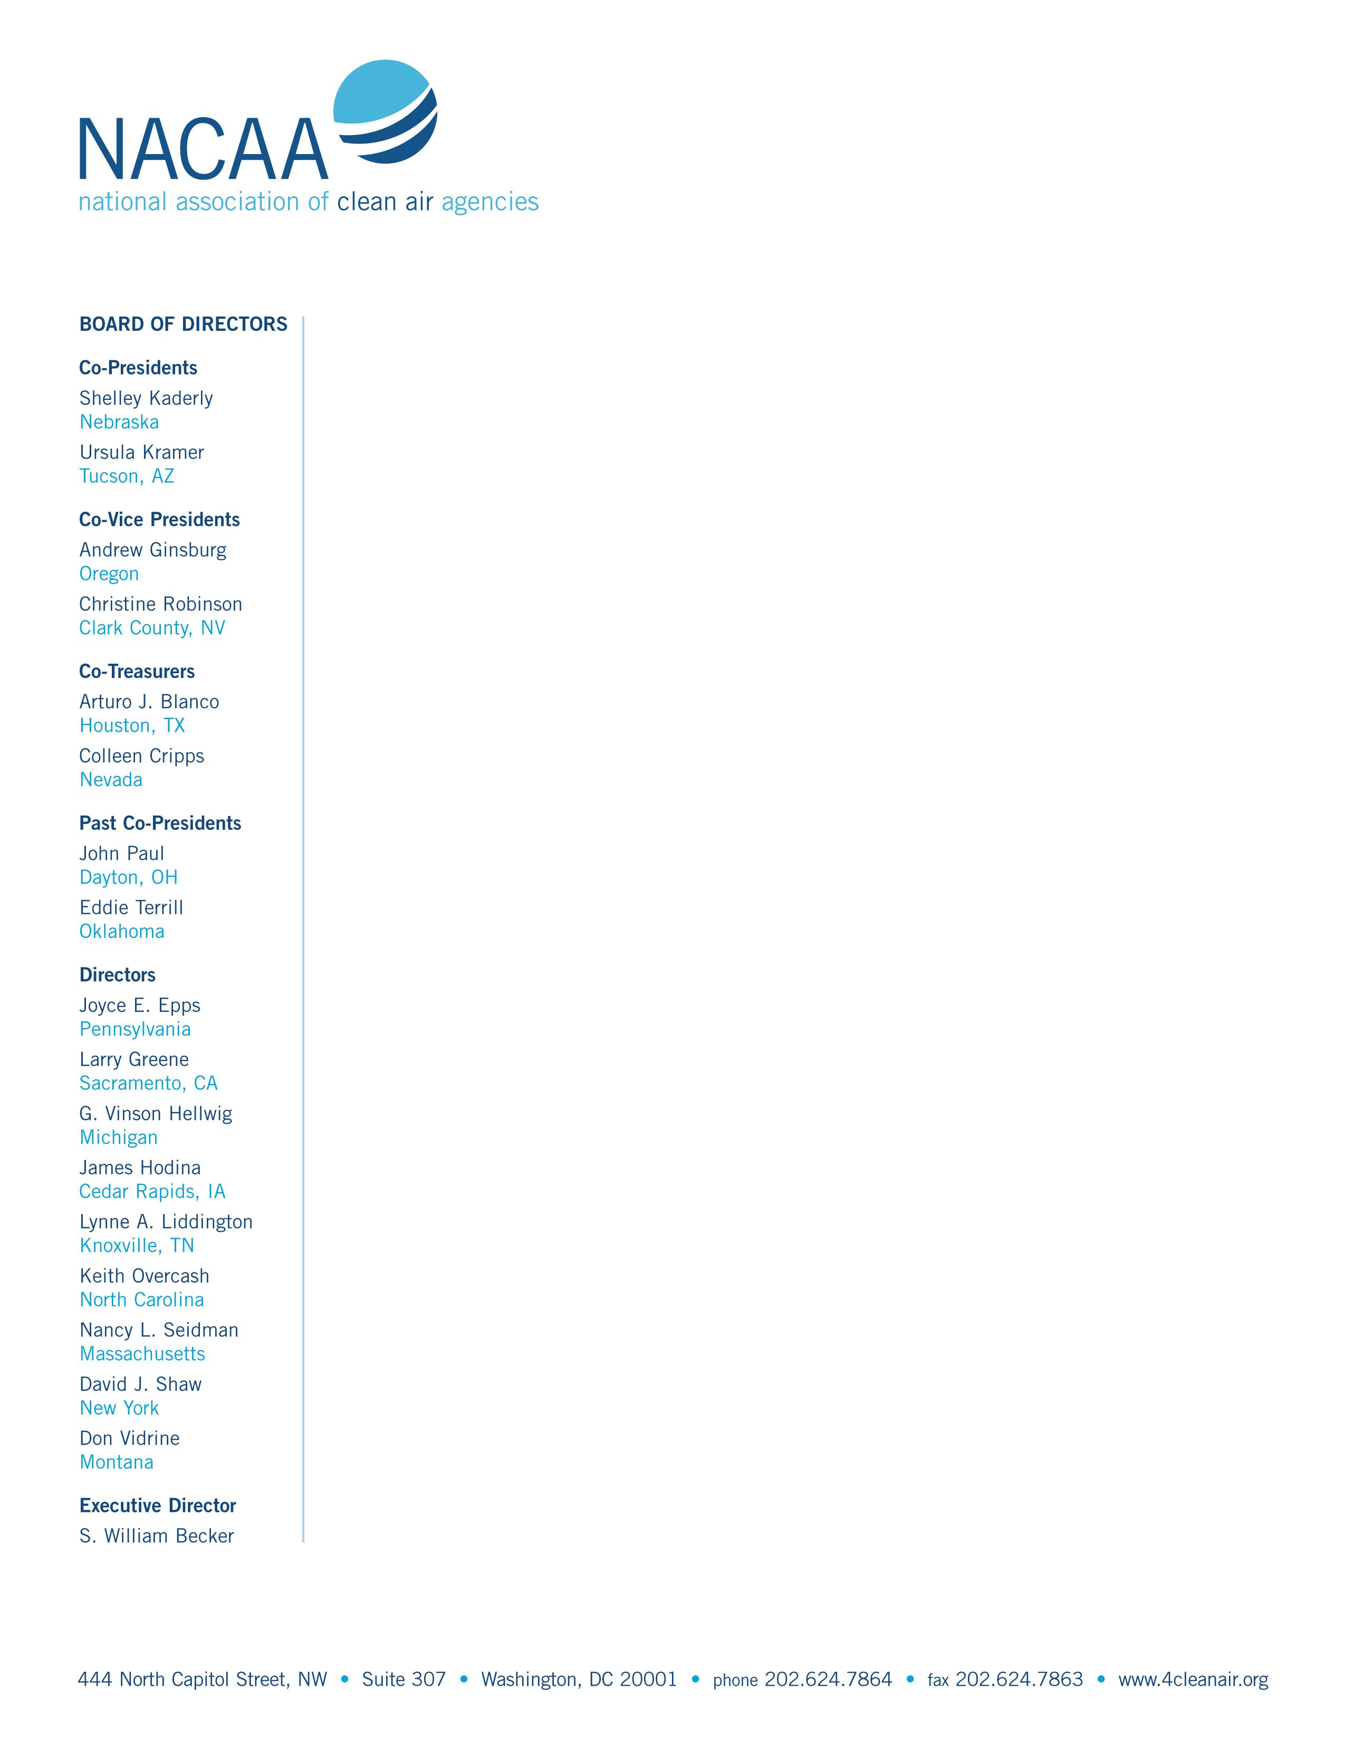

May 3, 2007

E-Docket ID No. EPA-HQ-OAR-2004-0094
U.S. Environmental Protection Agency
EPA West (Air Docket)
Room 3334, Mail Code 6102T
1200 Pennsylvania Avenue, NW
Washington, DC 20460

Dear Sir/Madam:

On behalf of the National Association of Clean Air Agencies (formerly known as STAPPA and ALAPCO), thank you for this opportunity to comment on the proposed National Emission Standards for Hazardous Air Pollutants: General Provisions, which were published in the Federal Register on January 3, 2007 (72 Federal Register 69). The National Association of Clean Air Agencies (NACAA) is the national association of air pollution control agencies in 54 states and territories and over 165 metropolitan areas across the country.

As the preamble indicated, STAPPA and ALAPCO (now NACAA) held discussions with EPA to explore ways to encourage pollution prevention at sources of hazardous air pollution. The association was concerned that the agency’s “once in, always in” (OIAI) policy regarding Maximum Achievable Control Technology (MACT) standards presented obstacles to certain sources interested in reducing emissions through pollution prevention approaches. The association subsequently adopted a set of principles designed to provide qualifying sources with exemptions from the OIAI requirements. Generally, qualifying sources are those sources subject to a MACT standard (i.e., after the first compliance date) that subsequently reduce emissions through appropriate pollution prevention approaches to make them “minor” sources for the hazardous air pollutant(s) in question. We were pleased to see these principles generally reflected in EPA’s proposed rule (May 15, 2003) on this issue.

Unfortunately, EPA’s January 3, 2007 proposal bears little resemblance not only to our association’s principles, but even to the agency’s May 15, 2003 proposal. Accordingly, NACAA opposes this proposal and believes EPA should allow exemptions to the OIAI policy only for those sources that have reduced emissions through pollution prevention (e.g., source reduction as defined in the EPA Pollution Prevention Act of 1990). If EPA reverts to the provisions contained in the 2003 proposal, we recommend that the agency give full consideration to the attached comments, which we made regarding that proposal (dated July 14, 2003).

The Clean Air Act clearly intends that major sources of hazardous air pollutants achieve “maximum” emissions reductions. By mandating specifically that MACT reflect “the average emission limitation achieved by the best performing 12 percent of the existing sources,” Congress was ensuring that major sources of hazardous air pollutants would be well controlled. The proposed OIAI rule, however, removes that level of public health protection and, instead, effectively establishes MACT as merely a point just below the major source threshold.

The most compelling reasons why relaxing the OIAI policy (for other than pollution prevention projects) is inadvisable can be found within EPA’s own memorandum on this subject, signed by John Seitz on May 16, 1995 (page 9):

EPA believes that this once in, always in policy follows most naturally from the language and structure of the statute. In many cases, application of MACT will reduce a major emitter’s emissions to levels substantially below the major thresholds. Without a once in, always in policy, these facilities could “backslide” from MACT control levels by obtaining potential-to-emit limits, escaping applicability of the MACT standard, and increasing emissions to the major-source threshold (10/25 tons per year). Thus, the maximum achievable emissions reductions that Congress mandated for major sources would not be achieved. A once in, always in policy ensures that MACT emissions reductions are permanent, and that the health and environmental protection provided by MACT standards is not undermined.

In the proposal, EPA indicates that it is unlikely that sources that currently emit below the major source levels would increase their emissions as a result of this rule. Specifically, EPA states that the control devices that major sources have installed to satisfy the MACT requirements are designed to operate a certain way and cannot be operated such that only partial emission reductions result. Therefore, sources that have met a certain emission level would maintain that level of control. We do not agree with this assumption. First, control devices can be operated at different levels of efficiency. Because the costs related to operating controls at less efficient levels can be lower, it is likely that sources will decrease the efficiency, thereby allowing emissions to increase. Additionally, since potential-to-emit is calculated through the use of averages over time, sources could stop controlling emissions for part of the time and still remain just below the major source threshold. While EPA expresses confidence that the rule will not result in backsliding, there is nothing in the proposal that would prevent sources from increasing their emissions.

NACAA is concerned that allowing sources to be reassigned as minor sources at any time would remove affected sources from the Title V program. This would undermine enforcement, inspection and monitoring requirements that are part and parcel of the Title V program. Additionally, NACAA has recommended that the Air Emissions Reporting Requirements rule call for Title V facilities to submit hazardous air pollutant (HAP) emissions data and indeed many states already supply some HAP data for major sources. Allowing sources that are subject to the MACT to become area sources and avoid major source permitting requirements will reduce the amount of quality inventory data available to EPA for its regulatory decision making. Additionally, since minor sources are not required to pay Title V fees, the permitting and related costs, which could be substantial, would no longer be supported by fees.

We are also concerned that sources that are not subject to MACT are also not covered by the Residual Risk standards under Section 112(f). A change in the OIAI restrictions would provide a loophole that would allow sources that were once major to escape the important Residual Risk review. This is even more troubling in the case of a source that used to be subject to MACT and then subsequently, because of the relaxation in the regulations, increases its emissions to just below the major source cut off. These sources could be the source of significant risk, yet they would not be evaluated and regulated for the residual risks they pose.

While we oppose EPA’s proposed rule, and urge the agency not to proceed with it, we will offer comments on the implementation issues raised in the proposal. EPA requested comment on whether sources that were “major,” then became minor sources and then became major sources again should have additional time to comply with the MACT if the standard had changed since the last time it was subject to the MACT. We believe that in such a situation a source should comply immediately, since the operators will have known about the change in the MACT prior to deciding to increase the source’s emissions again. Incidentally, such a scenario would cause tremendous confusion and effort with respect to issuing a Title V permit, then a minor source permit, then another Title V permit. These logistical difficulties are not addressed in the proposal.

Likewise, if a facility becomes a minor source and is then subject to Generally Available Control Technology standards, it should be in compliance immediately. Any source that is allowed to change its major or minor source status should be cognizant of the requirements and should not be granted additional time to comply.

In conclusion, NACAA believes that the proposal is flawed and that EPA should rescind it. Instead, EPA should allow exemptions to the OIAI policy only to sources that have decreased emissions through the use of pollution prevention strategies. Further, if the agency proposes a rule similar to the 2003 proposal, we urge EPA to make changes to address the recommendations and issues NACAA discussed in its comments on the 2003 proposal.

Thank you for this opportunity to comment on the proposal. Please contact us if we can provide additional information.

Sincerely,
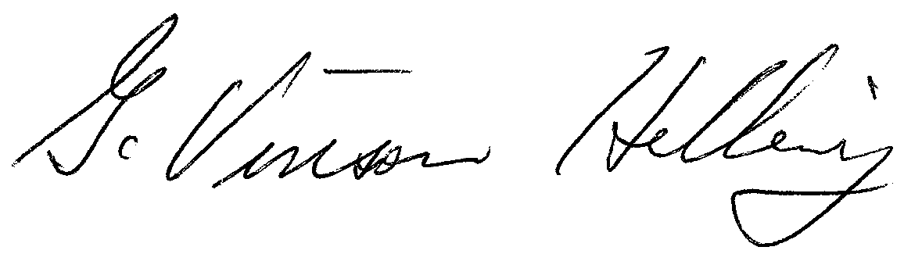
Vinson Hellwig
Michigan
Co-Chair
NACAA Air Toxics Committee

