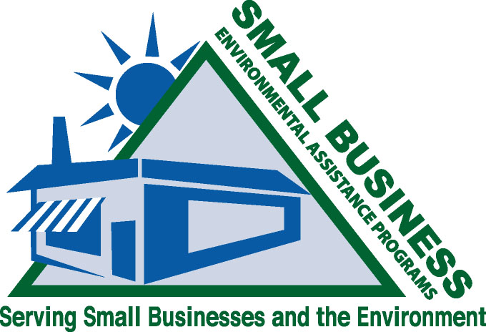
December 30, 2010

Office of Advocacy
U.S. Small Business Administration
409 3rd Street, SW
Washington, DC 20416

Transmitted via email: advocacy@sba.gov

Attention: Small Business Regulatory Review and Reform Initiative

Dear Sir or Madam:

The state Small Business Ombudsman and Small Business Environmental Assistance Programs (SBO/SBEAP) were created under s. 507 of the Clean Air Act Amendments of 1990. For more than 15 years, the SBO/SBEAPs have provided extensive, hands-on assistance to small businesses to help them understand and comply with environmental regulations. The National Steering Committee for the national network of state Small Business Ombudsman and Small Business Environmental Assistance Programs thanks you for the opportunity to nominate the National Ambient Air Quality Standards (NAAQS) for Ozone for review under the Small Business Regulatory Review and Reform Initiative. The SBO/SBEAPs, through their Technical Air Subcommittee, review proposed rules to assess their affects on small businesses. The Technical Air Subcommittee has more than 50 members representing 9 of the 10 EPA regions and 25 states. Comments from the National Steering Committee for SBO/SBEAPs reflect a wide range of experience with the efforts of small business to comply with such standards.

The U.S. Environmental Protection Agency proposed changes to the NAAQS for ozone in the Federal Register on January 19, 2010 in Docket ID No. EPA–HQ–OAR–2005-0172. The change would lead to additional compliance requirements for small commercial and industrial sources of emissions. As a result of lowering the ozone standard, states would be required to implement rules to ensure compliance with the NAAQS. The implementation and enforcement of these rules in the form of lower emission limits for processes using volatile organic compounds (VOC) would greatly impact small businesses.

Small businesses engaged in surface coating, automotive repair and refinishing, miscellaneous manufacturing, and many other activities use products and conduct processes that emit VOCs. The rules would limit the type and effectiveness of coatings, adhesives, and cleaning solvents used in small industrial applications. Small businesses would be required to change current manufacturing processes to meet lower VOC levels. In some cases, the new rules would require the installation of costly emission control systems to meet new VOC emission limits.

In addition, the proposed changes may result in a large number of new counties in states across the country being designated as non-attainment for ozone for the first time. Each of these counties includes small businesses that may be impacted by the proposed rule. Not only would the small businesses in the newly designated counties be affected by the new standards, there may be lower permit thresholds bringing many more into the permit system. These businesses could now fall under the Title V program which is an added expense requiring more extensive recordkeeping and reporting. Businesses could avoid the Title V program by putting federally enforceable conditions on their operations; however, that limits incentives to grow. One solution, although extremely burdensome, is for these small businesses to move their entire operations to an attainment area.

The proposed changes to the NAAQS for ozone would add to the disproportionate level of regulation burdening small business, as described in the SBA study titled “The Impact on Regulatory Costs on Small Firms” (W. Mark Crain, 2005). Also, a September 2010 report discusses the current regulatory impact on the 70 area sources and the cumulative effect with more regulations. The report states, “The costs of environmental regulations appear to be the main driver when determining the severity of the disproportionate impact on small firms.” The report also says, “Compliance with environmental regulations costs 364 percent more in small firms than in large firms.” (Nicole V. Crain and W. Mark Crain, Lafayette College, Easton, PA, Sep. 2010)

This proposed ozone rule is a good example of how decisions made at the federal level lead to state environmental rules compounding the cost of compliance for small businesses. Thank you for this opportunity to provide input on federal regulations that require review and reform. If you would like to discuss any of these issues please contact Barbara Johnson, Co-Chair of the NSC Technical Air Subcommittee at 800-578-8898.

Sincerely,
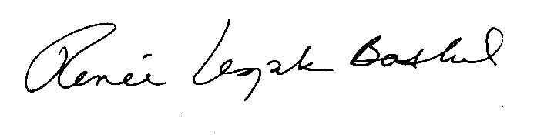
Renee Lesjak Bashel
Chair, National Steering Committee for SBO/SBEAP

cc: Jan King, USEPA OAQPS
Joan B. Rogers, USEPA Asbestos and Small Business Ombudsman
Kevin Bromberg, US SBA Office of Advocacy

