http://www.smallbiz-enviroweb.org/NSC/Subcommittees/Technical.aspx
Technical SUBCOMMITTEE
The charge of the subcommittee is to look at technical issues and rulemakings that are of interest and impact to small business and consequently to the Small Business Assistance Programs. Technical issues and interests were approached as a basic building block in the early foundation of the National Steering Committee. Central to the subcommittee's goals has been the desire to get involved in EPA's rulemakings, policy decisions, and guidance development in the representation of small business interests.

Mission
June 2009
Volume 6, Issue 1

Current Projects

- Area Source NESHAPS
  - Paint Stripping and Misc Surface Coating rule outreach materials and implementation issues
  - Dry Cleaner Rule corrections
  - Gasoline Distribution and Bulk Storage implementation issues
  - Plating and Polishing and 9 Metal Fabrication Operations initial notifications
- Submit recommendations to SBA for Regulatory Review and Reform (R3)
  - previous nomination in Top 10 regarding dry cleaner testing requirements is under review by EPA
- Maintain OAQPS and RTP Relationships
  - sharing implementation tools with area source program

Past Projects

- OIAI proposal to change policy
- 507 Enforcement Policy
- PTE policy
- NACAA Representation
- Wood Furniture MACT
- Surface Coating of Plastic Parts MACT
- Working Relationship with OAQPS and RTP
- Boiler MACT

Get Involved

The Technical Subcommittee is happy to welcome anyone with an interest in any of these issues. Please contact Renee Lesjak Bashel for information on conference call times and to be added to the e-mail Distribution lists.

Join us for the Technical Subcommittee Working Session on June 4th, 2:00 pm, at the National SBEAP/SBO Conference in Louisville, KY:
- Tentative Agenda
  - Informal follow up on SBA R3 recommendations with Office of Advocacy
  - Potential for new partnership with ASBO in EPA rule development process
  - Search for new Chair

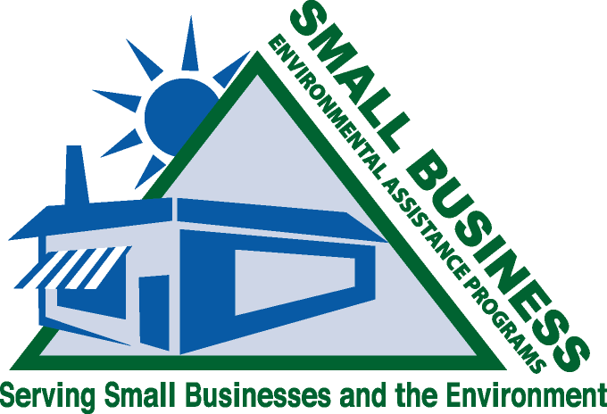

Members
Member Name | Region | Phone | Email
Ky Asral | Region II | 609-292-3600 | kasral@dep.state.nj.us
Keith Barnett | EPA | 919-541-5605 | barnett.keith@epa.gov
Renee Lesjak Bashel (Chair) | Region V | 608-264-6153 | renee.bashel@wisconsin.gov
Joni Canterbury | Region VIII | 303-692-3175 | joni.canterbury@state.co.us
Rick Carleski | Region V | 614-728-1742 | rick.carleski@epa.state.oh.us
Leslie Churilla | Region IV | 404-362-4854 | leslie.churilla@dnr.state.ga.us
Erin Conley | Region V | 217-785-4557 | erin.conley@illinois.gov
Kerri Cope | Region IV | 502-564-0323, x148 | kerri.cope@ky.gov
Jim Coyle | Region II | 518-402-7462 | coyle@nysefc.org
Bill Dunagan | Region III | 215-573-2019 | wdunagan@wharton.upenn.edu
Mandy Ellifritz | Region VI | 325-698-6104 | mellifri@tceq.state.tx.us
Annette Fulgenzi | Region V | 217-524-5199 | annette.fulgenzi@illinois.gov
Rebecca Hillwig | Region X | 503-229-5376 | hillwig.rebecca@deq.state.or.us
Kim Grosenheider | Region V | 651-757-2170 | kim.grosenheider@state.mn.us
Barbara Johnson | Region VII | 785-452-9456 | barblj@ksu.edu
Sara Johnson | Region I | 603-271-1379 | sara.johnson@des.nh.gov
Larry Lashley | Region VI | 318-676-5088 | larry.lashley@la.gov
Joan Meitl | Region X | 208-426-1839 | joanmeitl@boisestate.edu
Judy Mirro | Region I | 802-241-3745 | judy.mirro@state.vt.us
Steve Mohr | Region II | 518-402-7462 | mohr@nysefc.org
Tom Nakley | EPA | 202-566-2824 | nakley.thomas@epa.gov
Todd Nein | Region V | 614-387-3062 | todd.nein@aqda.state.oh.us
Dan Nickey | Region VII | 319-273-8905 | daniel.nickey@uni.edu
Sharon Nizich | EPA | 919-541-2825 | nizich.sharon@epa.gov
Tony Pendola | Region IV | 919-733-0824 | tony.pendola@ncmail.net
Terry Polen | Region III | 304-926-0499 | terry.l.polen@wv.gov
James Robinson | Region IV | 803-896-8984 | robinsjc@dhec.sc.gov
Joan Rogers | EPA SBO | 202-564-6568 | rogers.joanb@epa.gov
Steve Roseberry | Region VIII | 307-777-7347 | sroseb@wyo.gov
Linda Sadler | Region IV | 615-532-0779 | linda.sadler@state.tn.us
Liz Sapio | Region VIII | 303-692-2135 | emsapio@cdphe.state.co.us
Mark Shanahan | Region V | 614-728-3540 | mark.shanahan@aqda.state.oh.us
Jackie Sims | Region V | 217-782-9333 | jackie.sims@illinois.gov
Marylyn Stapleton | Region II | 340-774-3320 | stapleton.marylyn@vidpnr-dep.org
Mark Stoddard | Region V | 317-233-1039 | mstoddar@idem.in.gov
Kenya Stump | Region IV | 502-564-0323, x134 | ckeny2@uky.edu
Angela Suber | EPA | 202-566-2827 | suber.angela@epa.gov
Glenda Swierc | Region VI | 361-825-3421 | gswierc@tceq.state.tx.us
Aneka Swanson | Region V | 651-757-2175 | aneka.swanson@state.mn.us
Lucy Thompson | Region VII | 573-526-2414 | lucy.thompson@dnr.mo.gov
Sarah Walls | NCAP Representative | 817-877-2811 | swalls@canteyhanger.com
Paula Zampieri | EPA | 202-566-2496 | zampieri.paula@epa.gov
Audrey Zelanko | Smallbiz Home Page | 724-452-4722 | zelanko@smallbiz-enviroweb.org

