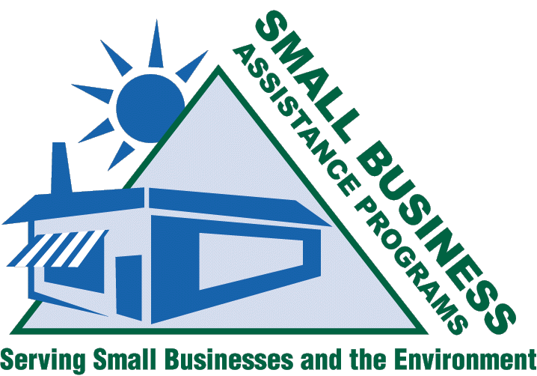
http://www.smallbiz-enviroweb.org/sba/technical_subcommittee.html
Technical SUBCOMMITTEE

Mission
February 2005
Volume 2, Issue 1
Renee Lesjak Bashel | (608) 264-6153 | rlesjakbashel@commerce.state.wi.us | Autobody Project, STAPPA/ALAPCO
Jim Coyle | (518) 402-7462 | coyle@nysefc.org
Amelia Gooding | (217) 785-4557 | amelia_gooding@commerce.state.il.us | Air Toxics
Chuck McCarty | (804) 698-4335 | crmccarty@deq.state.va.us
Tom Nakely | (202) 566-2824 | nakley.thomas@epa.gov
Jackie Sims | (217) 782-9333 | jackie.sims@epa.state.il.us
Dan Nickey | (319) 273-8905 | nickey@uni.edu | Autobody Project
Tony Pendola | (919) 733-0824 | tony.pendola@ncmail.net | Residual Risk-Dry Cleaners, Ready Mix Concrete
Terry Polen | (304) 926-0440, ext. 1381 | tpolen@wvdep.org
Richard Rasmussen | (804) 698-4394 | rgrasmussen@deq.virginia.gov | Committee Chair
James Robinson | (803) 896-8984 | robinsjc@dhec.sc.gov
Linda Sadler | (615) 532-0779 | linda.sadler@state.tn.us
Mark Shanahan | (614) 728-3540 | mark.shanahan@aqda.state.oh.us | Autobody Project
Robert White | (916) 364-4106 | rwhite@sacberc.org
Kenya Stump | (859) 257-1131 | ckeny2@email.uky.edu
Ky Ashral | (609) 292-3600 | asral@dep.state.nj.us
Rudy Cartier | (603) 271-1379 | rcartier@des.state.nh.us | Air Toxics
Dan Clark | (307) 777-7388 | dclark@state.wy.us
Terrell Ferrreira | (916) 322-2467 | tferreir@arb.ca.gov
Annette Fulgenzi | (217) 785-4557 | annette.fulgenzi@commerce.state.il.us
Linda Hayes-Gorman | (541) 388-6146, x274 | hayes-gorman.linda@deq.state.or.us
Judy Mirro | (802) 241-3745 | judy.mirro@anr.state.vt.us
Mike Nelson | (651) 297-8615 | michael.nelson@pca.state.mn.us | TBAC and EGBE Delisting Autobody Project
Rick Carleski | (614) 728-1742 | rick.carleski@epa.state.oh.us

Current Projects

- Autobody Project
- Area Source ID Project
- Title V Deferrals
- TBAC & EGBE Delisting
- Residual Risk-Dry Cleaners
- Implementation Tool Review
- Air Toxic Issues
- Maintenance of OAQPS and RTP Relationships
- STAPPA/ALAPCO Representation
- Identify Regional Issues
  - Biodiesel
  - Ready Mix Concrete

Members
The charge of the subcommittee is to look at technical issues and rulemakings that are of interest and impact to small business and consequently to the Small Business Assistance Programs. Technical issues and interests were approached as a basic building block in the early foundation of the National Steering Committee. Central to the subcommittee's goals has been the desire to get involved in EPA's rulemakings, policy decisions, and guidance development in the representation of small business interests.

Additional Autobody Project Members
Stephen Mohr, Dan Nickey, Frances Hartwell, Larry Lashley, Nick Melliadis, Phyllis Strong, Ron Dyer, Sally Tarowsky, Teresa Kinder, and Angela Suber.
Page 1 of 2
The Autobody Project is a crowning example of the work of the technical subcommittee. Working with Kim Teal (EPA), the SBAPs have established a productive, working relationship and have become an integral part of the rulemaking process. The goal of this project is to produce a “ sensible” area source MACT/GACT for this industry sector without burdensome and duplicative recordkeeping and reporting requirements.
The Technical Subcommittee is happy to welcome anyone with an interest in any of these issues. Please contact Richard Rasmussen for information on conference call times and to be added to the e-mail Distribution lists.

Autobody Project

Area Source ID Project
http://www.smallbiz-enviroweb.org/sba/technical_subcommittee.html
Technical SUBCOMMITEETEE
February 2005
Volume 2, Issue 1
GOALS:
- Correct EPA numbers for the number of affected facilities within each area source category
- Establish a “seat at the table” with EPA during the rule development process
- Aid in the maintenance and development of RTP relationships
- Establish SBAPs as a credible source of information regarding small business regulatory impacts
The subcommittee will continue to address the mission described above, focused on the direction determined from the working sessions at the 2005 SBO/SBAP National Conference in Biloxi, MS.

Be sure to check out technical session agenda items and feel free to drop in on the subcommittee’s scheduled meeting during the conference. If you have a concern or topic that needs discussion, do not hesitate to contact one of the committee members.

We are always looking for new topics and suggestions. Don’t forget to check out our website where you can find minutes from conference calls, newsletters, working session summary report/powerpoint slides from the 2003 SBO/SBAP National Conference held in Baltimore, Maryland, and comments sent to EPA regarding technical rules.

http://www.smallbiz-enviroweb.org/sba/technical_subcommittee.html

Also, be sure to check out the technology web page developed by the technical subcommittee. We are always looking for new materials and ideas.

http://www.smallbiz-enviroweb.org/pollution/technologies.html

Future Projects
Page 2 of 2

