Ky Asral | (609) 292-3600 | asral@dep.state.nj.us
Renee Lesjak Bashel | (608) 264-6153 | rlesjakbashel@commerce.state.wi.us | Committee Co-Chair, Autobody Project, STAPPA/ALAPCO
Rick Balazs |  | balazsr@saccounty.net
Eric Byrd |  | ejbyrd0@uky.edu
Rick Carleski | (614) 728-1742 | rick.carleski@epa.state.oh.us
Rudy Cartier | (603) 271-1379 | rcartier@des.state.nh.us | Air Toxics
Dan Clark | (307) 777-7388 | dclark@state.wy.us
Cathy Colglazier |  | ccolglaz@kdhe.state.ks.us
Jim Coyle | (518) 402-7462 | coyle@nysefc.org
Terrell Ferreira | (916) 322-2467 | tferreir@arb.ca.gov
Annette Fulgenzi | (217) 785-4557 | annette.fulgenzi@commerce.state.il.us
Amelia Gooding | (217) 785-4557 | amelia_gooding@commerce.state.il.us | Air Toxics
Linda Hayes-Gorman | (541) 388-6146, x274 | hayes-gorman.linda@deq.state.or.us
Larry Lashley |  | Larry.Lashley@LA.GOV | Autobody Project
Chuck McCarty | (804) 698-4335 | crmccarty@deq.state.va.us
Judy Mirro | (802) 241-3745 | judy.mirro@anr.state.vt.us
Tom Nakely | (202) 566-2824 | nakley.thomas@epa.gov
Todd Nein |  | Todd.Nein@aqda.state.oh.us
Mike Nelson | (651) 297-8615 | michael.nelson@pca.state.mn.us | TBAC and EGBE Delisting
Dan Nickey | (319) 273-8905 | nickey@uni.edu | Autobody Project
Tony Pendola | (919) 733-0824 | tony.pendola@ncmail.net | Residual Risk-Dry Cleaners, Ready Mix Concrete
Terry Polen | (304) 926-0440, ext. 1381 | tpolen@wvdep.org
Richard Rasmussen | (804) 698-4394 | rgrasmussen@deq.virginia.gov | Committee Co-Chair, Autobody Project
James Robinson | (803) 896-8984 | robinsjc@dhec.sc.gov
Linda Sadler | (615) 532-0779 | linda.sadler@state.tn.us
Mark Shanahan | (614) 728-3540 | mark.shanahan@aqda.state.oh.us | Autobody Project
Jackie Sims | (217) 782-9333 | jackie.sims@epa.state.il.us
Kenya Stump | (859) 257-1131 | ckeny2@email.uky.edu
Lee Tate |  | Lee_Tate@dnr.state.ga.us
Stacy Washington |  | WASHINSV@dhec.sc.gov
ADDITIONAL AUTOBODY PROJECT MEMBERS
Stephen Mohr (NY), Frances Hartwell (OR CAP), Nick Melliadis (CO), Phyllis Strong (MN), Ron Dyer (ME), Sally Tarowsky (ID), Teresa Kinder (MI), Angela Suber (DC), Sara Lippert (ME), and Andrew Macintosh (IN).
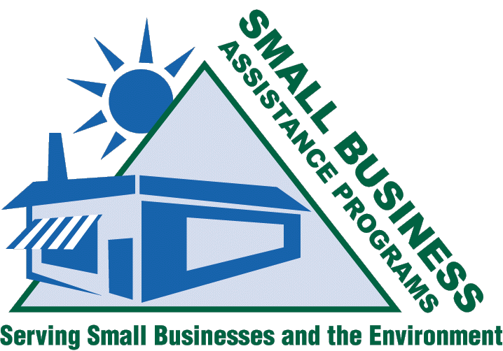
http://www.smallbiz-enviroweb.org/sba/technical_subcommittee.html
Technical SUBCOMMITTEE

Mission
March 2006
Volume 3, Issue 1

Current Projects

- Autobody Project
- Area Source ID Project
- TBAC & EGBE Delisting
- Residual Risk-Dry Cleaners
- MACT Implementation Tool Review
- Air Toxic Issues
- Maintenance of OAQPS and RTP Relationships
- STAPPA/ALAPCO Representation
- Identify Regional Issues
  - Biodiesel
  - Ready Mix Concrete

Members
The charge of the subcommittee is to look at technical issues and rulemakings that are of interest and impact to small business and consequently to the Small Business Assistance Programs. Technical issues and interests were approached as a basic building block in the early foundation of the National Steering Committee. Central to the subcommittee's goals has been the desire to get involved in EPA's rulemakings, policy decisions, and guidance development in the representation of small business interests.
Page 1 of 2
The Autobody Project is a crowning example of the work of the technical subcommittee. Working with Kim Teal (EPA), the SBAPs have established a productive, working relationship and have become an integral part of the rulemaking process. The goal of this project is to produce a “sensible” area source MACT/GACT for this industry sector without burdensome and duplicative recordkeeping and reporting requirements.
The Technical Subcommittee is happy to welcome anyone with an interest in any of these issues. Please contact Richard Rasmussen or Renée Lesjak Bashel for information on conference call times and to be added to the e-mail Distribution lists.

Autobody Project

Area Source ID Project
http://www.smallbiz-enviroweb.org/sba/technical_subcommittee.html
Technical SUBCOMMITTEETEE
March 2006
Volume 3, Issue 1
GOALS:
- Establish a “seat at the table” with EPA during the rule development process
- Aid in the maintenance and development of RTP relationships
- Establish SBAPs as a credible source of information regarding small business regulatory impacts
The subcommittee will continue to address its mission, focused on the direction determined from the working sessions at the 2005 SBO/SBAP National Conference in Biloxi, MS.

We are always looking for new topics and suggestions. Don’t forget to check out our website where you can find minutes from conference calls, newsletters, working session summary report/
powerpoint slides from the 2003 SBO/SBAP National Conference held in Baltimore, Maryland, and comments sent to EPA regarding technical rules.

Future Projects
Page 2 of 2

Technical Subcommittee Breakout Session Agenda
- Our subcommittee meeting is from 1:00-2:30 pm on Monday 3/27. The following are possible topics for the session:

- 1. Area Source ID project update – rule writer contacts made
- 2. Voluntary options for Area Source NESHAPs
- 3. Schedule for Area Source NESHAPs
- 4. Definition of GACT
- 5. Ozone transition – new RACT, applicability
- 6. Once-in-Always-in for MACT
- 7. Discussion of Autobody Refinishing Rule with Kim Teal (invited)

PLEASEJOIN US.

Technology Web Page
We are always looking for new materials and ideas.
http://www.smallbiz-enviroweb.org/
pollution/technologies.html

